MACH4METAL

metalworking machinery
Transito 21, 6909 DA Babberich, Netherlands
Tel. + 31 (0)316 – 247123
Fax. + 31 (0)316 - 247956
info@mach4metal.com

Bank No : 66.52.13.883
IBAN : NL33 INGB 0665 2138 83
BIC : INGBNL2A
VAT : NL 815393635B01

DOOSAN PUMA 400 LMC

- Make : DOOSAN
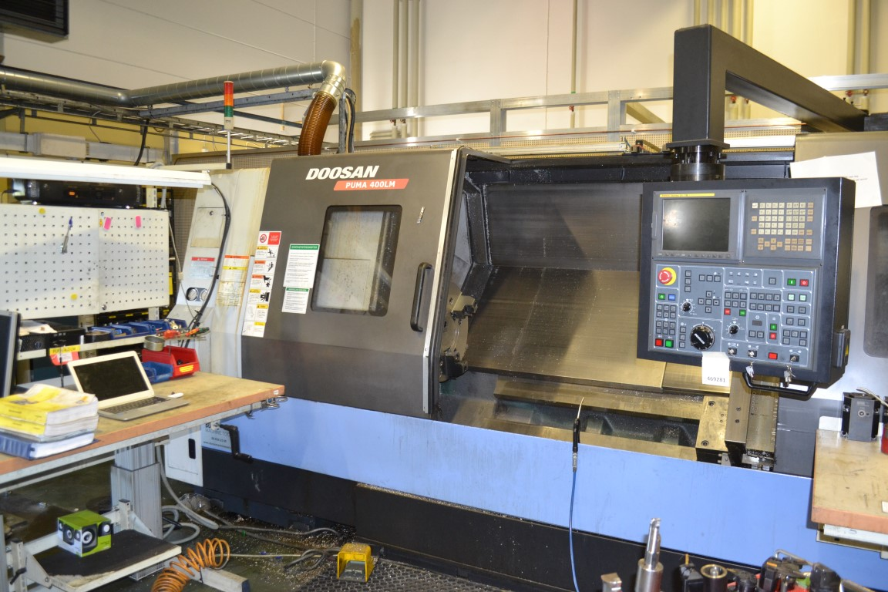
- Type : PUMA 400 LMC
- Age : 06 . 2008
- Serial : 3 SLM 3629

- Swing over slide : 770
- Swing over bed : 590
- DBC turning length : 2.000
- Spindle bore : 166

- Travel X slide : 357
- Travel Z slide : 2.155
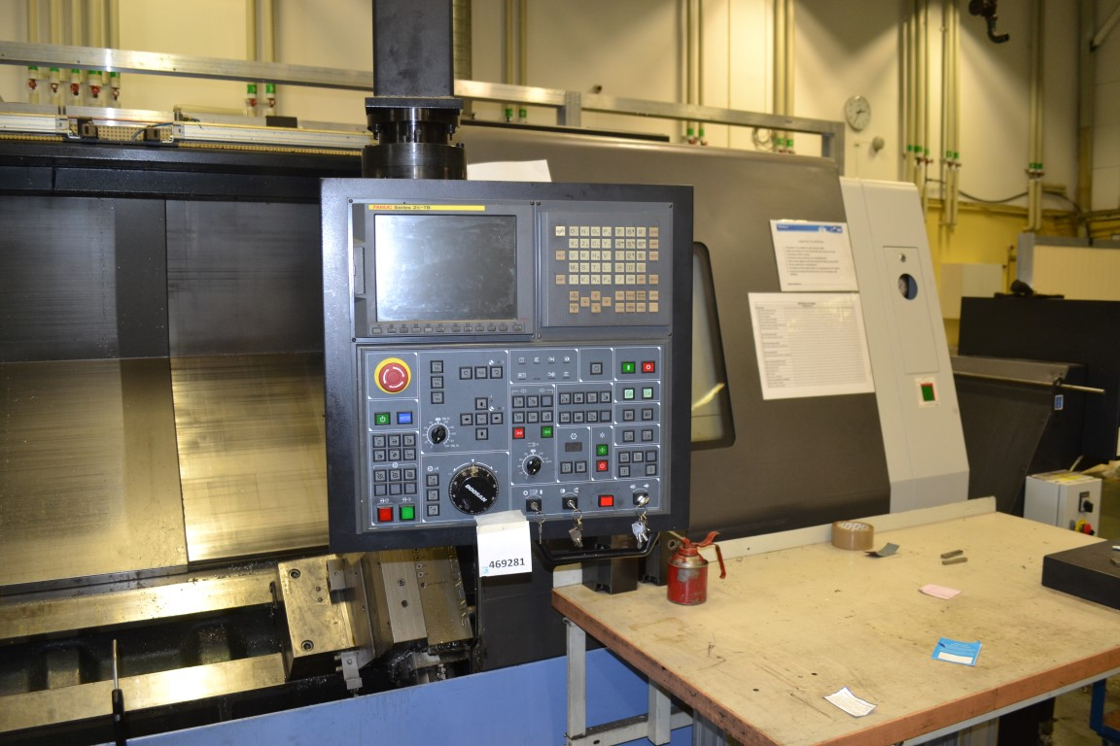
- Travel C index : 0.001 Gr

- Chuck Ø : 533
- Spindle speeds : 1500
- Spindle bore : 181
- Quill : 120
- Quill travel : 120

- Revolver : 12 stations
- Live tools : 11 kW
- Power : 30 kW
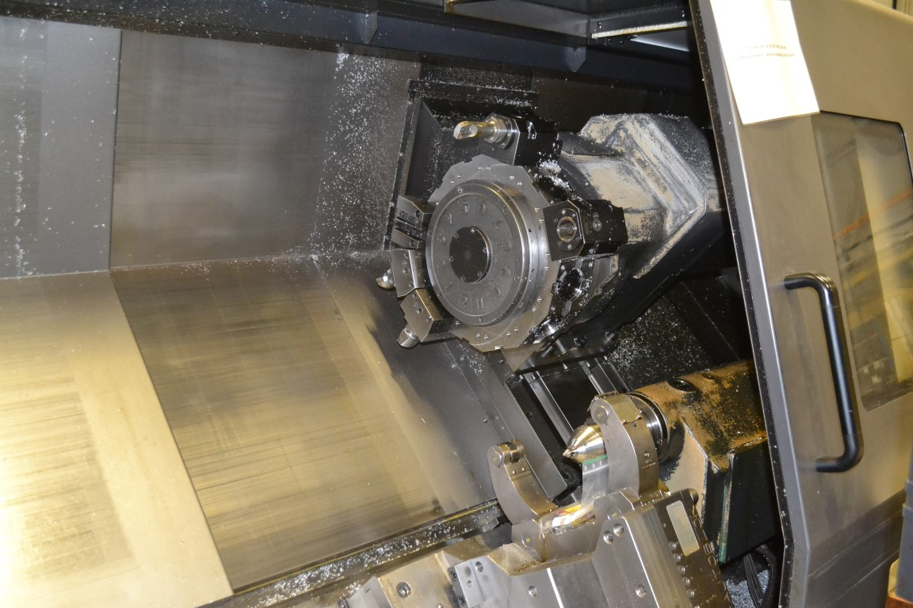

- Dimensions
- Length : 5.500
- Width : 2.200
- Height : 2.400
- Weight : 9.800

- Chip conveyor
- SMW Autoblock steady
- Tool eye
- Package with ca 20 sets jaws
- Optional live tool package 10 pieces

Please Note: The above information has been obtained to the best of our ability and belief from, and from the manufacturers where possible. It is given in good faith, but its accuracy can not be guaranteed. Accordingly, it will not form a representation or constitute contractual terms. We advise you to check any vital details!

